**Values’ distribution of the Affine Removed models. from left to right: BN’s input, pure BN (before affine), BN’s output (after affine). On miniImageNet**

**All Layers**

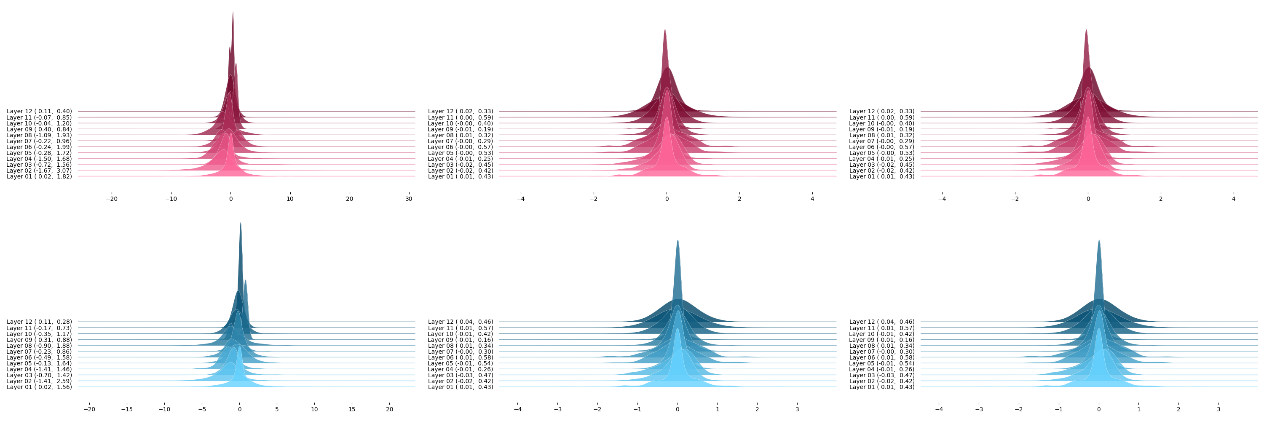

**Layer 2**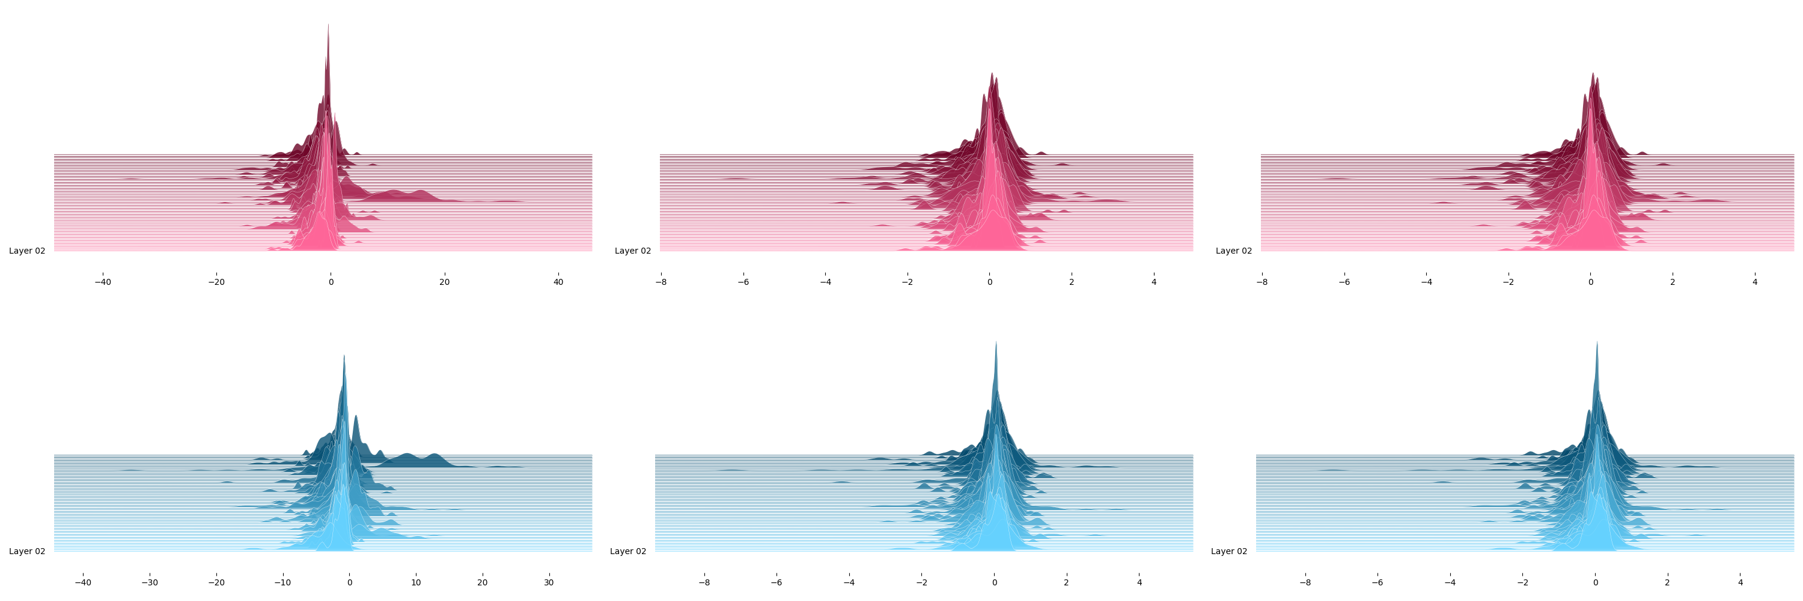

**Layer 3**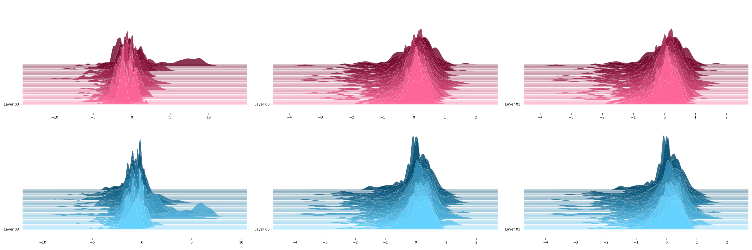

**Layer 2 channel 20**